# Using the Unity NodleSDK

The plug in is developed for Android and iOS, LTS versions.

## In a new project:

### For Android:

1. In Unity Hub - Create a new Android project

It is not required to use this template, you can use the blank 3D or other.

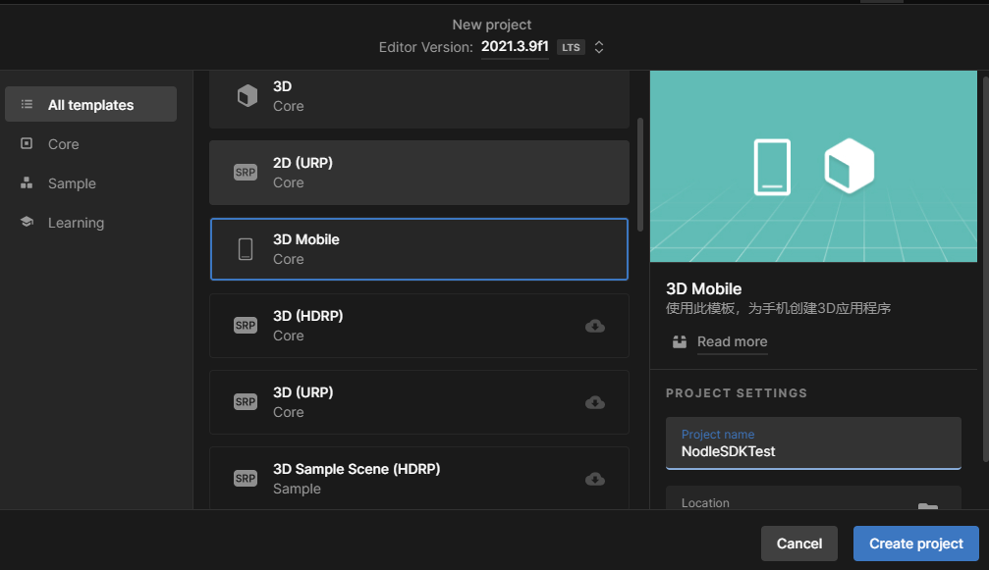

1. Switch to Android

Go to Build Settings

Switch to Android

1. Import package

We recommend to import the sample scene as well

If you receive a Notification to use TMP Essentials, it is ok

(If the letters do not appear in the buttons, is a minor Unity bug, close it and enter again they will appear)

1. Open the Sample Scene: Assets/Plugins/Nodle/SampleScene/SampleScene.unity

1. Select the MainCamera Object

1. In the inspector place your NodleKey, leave the “ss58:”.

1. Go to Build Settings

If you scene didn’t appear, click on the “Add Open Scenes”, and place it as 0 ( Drag the scene name to the top of the list )

****** DON’T Forget to fill the Player Settings details for your application.

### For iOS:

1. In Unity Hub - Create a new Android project

It is not required to use this template, you can use the blank 3D or other.

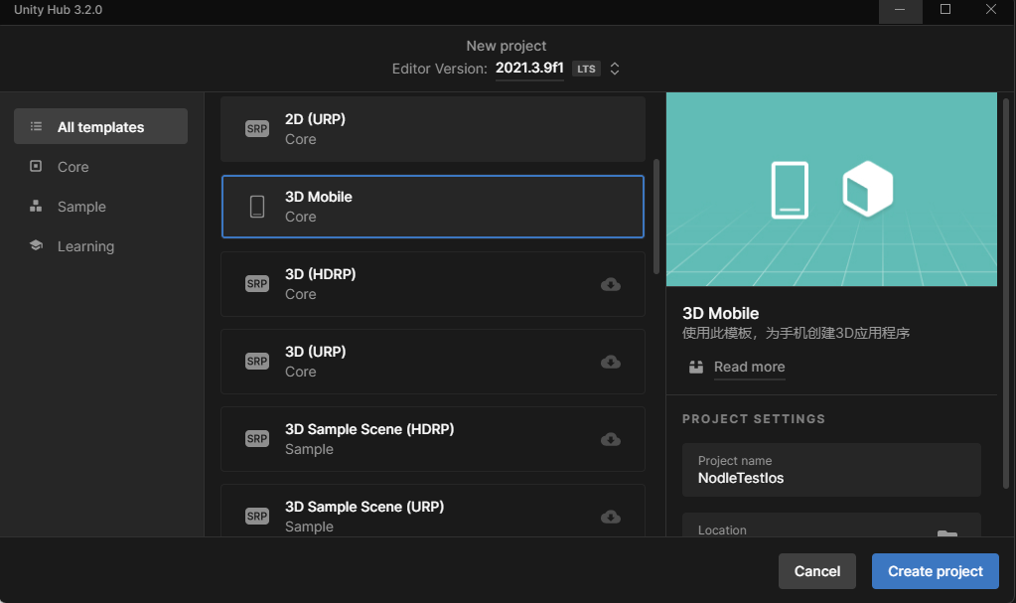

1. Switch to iOS

1. Import custom package

1. Open the Sample Scene

1. Import the TMP Essentials

(If the letters do not appear in the buttons, is a minor Unity bug, close it and enter again they will appear)

1. Select the Main camera to put the NodleSDK Key, leave the “ss58:”.

1. Open Build Settings – Add Open Scenes

****** DON’T Forget to fill the Player Settings details for your application.

### After Unity Build

1. After making the build into a build folder (only once)
2. Copy podfile com XCodeFiles to the root of the build folder
3. Go to the build folder with your terminal, and pod install
4. Open the Info.plist from the folder and copy the entries to the project’s info.plist
5. open the workspace file
6. Build or play

## The Sample Scene

Press Request location and request bluetooth

Press init -> start -> getevents

(iOS) The build folder is updated every time with unity build, there is no

need to create a new build folder, and all the changes in the info plist

remain, and the pods as well